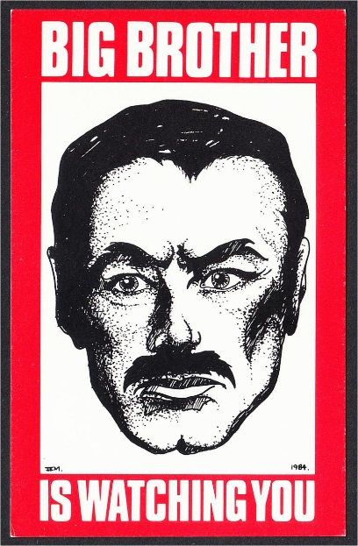

1984 Recycled Essay Assignment
“Recycle” your chapter work for use in making a full-on essay. (Use the quotes you already found, for example, just for Orwell’s use of setting, or “past under glass” symbols.) Make it Format #2. Follow The Stop! Sheet perfectly. Use a paragraph for each quotation you found on the topic you chose. Each paragraph needs an introductory sentence, a quotation from the book, a quotation from the real world, and a concluding sentence. Use MLA citation with in-text page numbers and a separate “works cited” page at the end. (The “works cited” page will cite 1984, the start and end “decorative” quotes, all your ”real world connection” sources, and will be titled “Works Cited.”)
Thesis
You will have to create a thesis statement that will tie together the bits of chapter work that you are using. Your thesis statement will be the second sentence in your essay. A reworded version of the same thesis statement will be the second-last sentence in your essay too.
Examples:
- In 1984 George Orwell often uses the image of the past preserved in glass to represent Winston’s quest to recapture what The Party has taken from the citizens of Oceania. (use as many examples from the book as you can, with a minimum of four)
- In 1984 George Orwell makes careful choices as to where scenes take place, using his description of them to amplify the atmosphere he is looking for in that scene. (use as many examples from the book as you can, with a minimum of four)
- In 1984 George Orwell traces Winston’s slow stealing back of some personal freedom and humanity for himself, in a series of landmark events. (present four ways or parts of the book in which Orwell clearly does this, using your quotes.)
- In 1984 George Orwell consistently draws out great sympathy for Winston from his readers. (present four ways or parts of the book in which he clearly does this, using your quotes.)
- In 1984 George Orwell repeatedly reveals that Winston Smith is a broken, angry person. (present four ways or parts of the book in which he clearly does this, using your quotes.)
- In 1984 George Orwell presents the idea that:
            - fear is extremely powerful when manipulating a society.
            - self-expression is a vital part of being one’s true self.
            - there really is such a thing as “true.”
            - sex is supposed to be secret and dirty,
            - sex is supposed to be romantic and wholesome.
            - knowledge of the past is vital.
            - language is incredibly important, and changing it changes not only how people speak, but how they think and feel.
(themes-related theses like the ones in “f)” are the easiest sort of thesis to use, for people looking to score marks in the 80s and 90s. For any thesis you choose, though, use a minimum of four examples from the book, with a paragraph for each)

